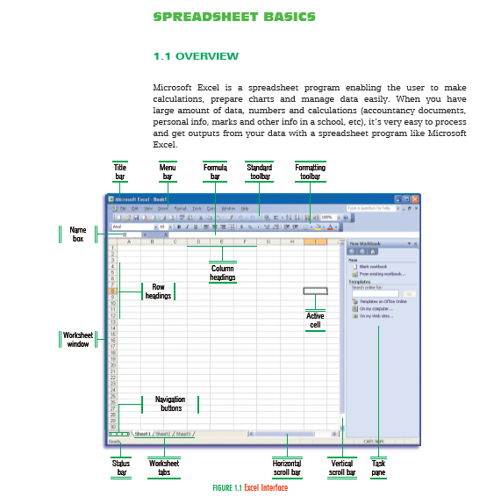

Cell: Microsoft Excel is made up of small boxes that are called cells. Each cell can have different properties and store different data. All cells have different addresses or names like “E5”, which means “the cell in column E and row 5”.
Row: A row is the adjacent cells horizontally adjacent to one another. Each row is named with a number and contains 256 (28) cells.
Column: A column is the cells vertically adjacent to one another. Each column is named with letter(s) A, B, C, IV and contains 65536 (216) cells.
Worksheet: A worksheet contains both rows and columns (28 x 216 = 224 or 16.777.216 cells.)
Workbook: A workbook is made up of worksheets. Each worksheet is like a paper in a file (Workbook) that contains all formulas, links, and data in tabular format. Theoretically, a workbook can have as many worksheets as you want, but it’s not suggested that you store too much information in a workbook. It’s better to store it on different but related files.
Navigation buttons: They are placed at the bottom left corner of the active workbook. You can change the current worksheet using navigation buttons
The name box: It shows the name or address information of the active cell. Using this box, you can change the reference name of the selected area. On the right side of the box, there is an arrow which is used to show the user defined area names. When you select one of these names Excel automatically selects and shows that range.
The formula bar: It is used to define formulas in the active cell.
The status bar: It shows messages or brief information about the current situation.

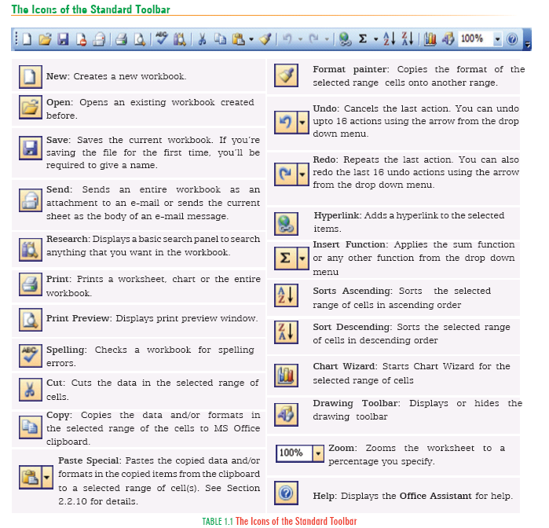
1.3 STANDARD TOOLBAR
The Standard Toolbar provides quick access to commonly used actions. Each action is represented by an icon. When you move your mouse pointer over an icon, it is highlighted and a descriptive tool tip appears. Locate the icon for the action you want to perform click on the icon.

